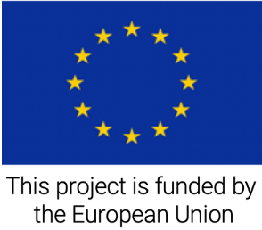
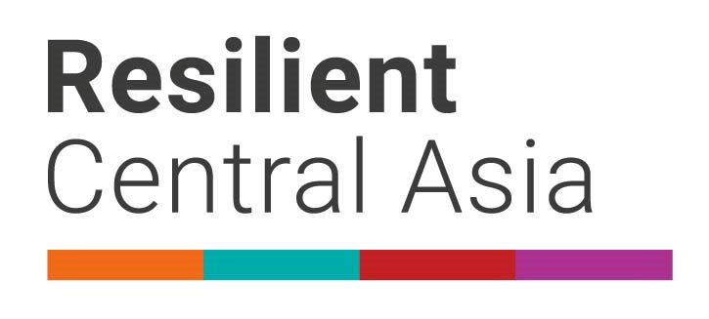

August 2022

The International Day for Disaster Risk Reduction 2022

#EarlyAction
#DRRDay

Sing for Resilience

The United Nations General Assembly has designated October 13th as the International Day for Disaster Risk Reduction to promote a global culture of disaster risk reduction. It is an opportunity to acknowledge the progress being made toward reducing disaster risk and losses in lives, livelihoods and health in line with the Sendai Framework for Disaster Risk Reduction 2015-2030 adopted at the Third UN World Conference on Disaster Risk Reduction in Japan in March 2015.

In 2016, the UN Secretary-General launched “The Sendai Seven Campaign” to promote each of the seven targets over seven years. The 2022 target is Target G: “Substantially increase the availability of and access to multi-hazard early warning systems and disaster risk information and assessments to people by 2030”.

In keeping with the Day’s focus on the impact that disasters have on people’s lives and well-being, this year’s theme is about highlighting the importance of increasing the disaster risk information. Taking into consideration that disaster risk communication via songs and music contributes to increasing awareness, in dedication of the International Day for Disaster Risk Reduction, UNDRR announces musical contest “Sing for Resilience”.

Everyone has an opportunity to show their talent and contribute to the safety of their community by raising awareness on disaster risk reduction by submitting their songs. Please read below the terms and condition of the Contest.

Format
• songs must be two-minute maximum of running time
• songs should be submitted in mp3 format (please send lyrics in MS Word format)
• songs should be in English, Russian, or Turkmen
• add a line in the song “early warning and early action for all”
• submission of the video-clip with a song (optional)

Eligibility requirements:

Anyone with musical skills is eligible to enter the contest.

Technical specifications for submission:

All materials should be submitted electronically by September 30, 2022 to: ogulgerek.annayeva@un.org

The submitted material must be an original creation - no copyrighted materials may be used.

The participant must certify and warrant that the submitted material does not violate the rights of a third party or any copyright. UNDRR is not responsible for intellectual property violations that might have resulted through the submissions.

Judging and notification of selected participants:

The Contest closes at 23:59 pm on September 30, 2022 qualifying materials will be judged on adherence to the Contest theme through its message clarity, composition, and overall presentation. UNDRR will appoint a jury to judge the entries.

The selected entry will be announced on October 10, 2022 and the winner will be notified by e-mail.
Rights and ownership:
By submitting their works to UNDRR, participants agree to grant UNDRR free of charge the right to use the submitted work and media in any manner, including without limitation, the right to publish, adapt, distribute, copy, display or translate in printed or electronic media even if they are not the winning entries.
Award:
The winner’s song will be publicised on UNDRR’s website. In addition, selected candidates will be invited to events dedicated to disaster risk reduction in UN House and the winner will be asked to perform in UN events dedicated to disaster risk reduction.

Background information
The contest is organized within the EU-funded project “Strengthening disaster resilience and accelerating implementation of Sendai Framework for Disaster Risk Reduction in Central Asia”, implemented by the United Nations Office for Disaster Risk Reduction (UNDRR), which aims to support countries of the region in implementing the Sendai Framework priorities. The project supports strengthening regional coordination, development of regional DRR strategy, national disaster loss accounting systems, and community level disaster risk reduction. On the local level, the project supports development of disaster resilience strategies of capital cities. For this project, the EU committed EUR 3,750,000 for the three-year implementation.

For additional information please contact

Mr. Abdurahim Muhidov, UNDRR Regional Programme Coordinator, at: muhidov@un.org
Ms. Ogulgerek Annayeva, UNDRR National Technical Officer, at: ogulgerek.annayeva@un.org
Delegation of the European Union to Kazakhstan, at: delegation-kazakhstan-pic@eeas.europa.eu

