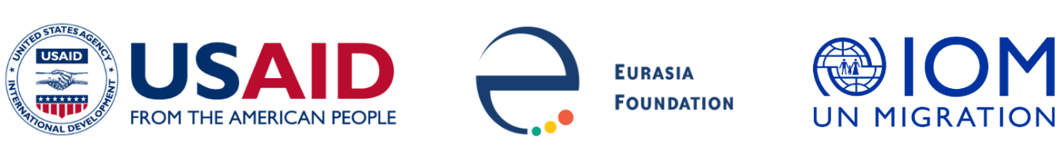

Social Innovation in Central Asia

Institutional Development Program

Request for Applications

Background
The International Organization for Migration in Turkmenistan (IOM), in partnership with Eurasia Foundation (EF), announces a call for applications for public organizations and associations to participate in the Institutional Development Program (IDP). IDP in Turkmenistan is part of IOM’s “Building Youth Resilience through Community Engagement” project and Social Innovation in Central Asia (SICA), a five-year program funded by the United States Agency for International Development (USAID).

The Institutional Development Program is a 14-month program designed to empower established and new public organizations and associations (POA) to be financially viable and responsive to their constituents. IDP will focus of strengthening organizational capacity of public organizations and increasing of knowledge bases of employees of POAs.

Overview
The Institutional Development Program consists of a series of closely interconnected activities involving rapid assessments of organizational capacities of public organizations, tailored trainings, mentoring, coaching and grant funding for institutional development projects.

Institutional Assessments
EF-trained institutional development experts will conduct initial baseline institutional assessments to measure organizational capacity of the POAs through interviews with POA staff members, leadership and select representatives of their constituencies and other stakeholders.

Grant Funding
Organizations participating in IDP that have demonstrated a commitment to institutional development of their organizations may apply for Institutional Development Grants (ID Grants). ID Grants will range in size between $10,000 and $17,000, and the expected length of projects is up to 10 months. POAs must develop proposals after completing their institutional assessments and reviewing their results. The recommendations they receive will serve as the basis for these project proposals. Applicants will be assisted by institutional development experts on proposal development to ensure ideas and plans are documented properly.

Mentoring, Coaching And Consulting
POAs awarded Institutional Development Grants for their projects will receive mentorship and coaching from experts during project implementation. The experts also will monitor progress against established targets.

Online Capacity Development School
All organizations participating in IDP will have the opportunity to enroll their staff and volunteers in a series of advanced online courses and in-person trainings focused on innovative capacity building topics. Illustrative courses include:
- Strategic Planning
- Effective Communications
- Resource Mobilization
- Monitoring and Evaluation
- Use of Innovative Digital Tools
- Social Enterprises

Final Institutional Assessments
At the end of the Institutional Development Program, the participating organizations’ progress will be assessed again, and actionable recommendations for further development will be shared with each organization participating in IDP. All POAs successfully demonstrating progress in their organizational development will be presented with certificates of completion from the program.

Eligibility
Eligible applicant organizations may range from traditional POAs and service delivery organizations with years of experience to more recently registered organizations. Organizations applying for IDP must be legally registered as public organizations or associations, as defined by the laws of Turkmenistan.

Evaluation Criteria
The selection process is open and competitive, and applications will be scored using the following criteria:
- Clear rationale and motivation for applying to participate in the Institutional Development Program (50% of total possible score)
- Effectiveness and appropriateness of the proposed plan for institutional development (25% of total possible score)
- Demonstrated impact and results of previous projects (25% of total possible score)

All applicants will be informed of the selection decision via email.

If additional information or clarification on applications is needed, the applicant(s) will be notified in writing and will be asked to submit additional information and/or documentation. The program team will also organize Q&A sessions, which will be advertised additionally.

Any questions regarding this contest should be submitted to Gulshirin Annadurdyeva, Project Manager, via email (gannadurdiye@iom.int), with “IDP Question” in the subject line.

Application Process and Deadlines
All interested applicants must submit applications to gannadurdiye@iom.int by email, with “IDP Contest” in the subject line.

Interested applicants must submit their applications no later than 23:59 Ashabat time (GMT+5) on 16 October2022.

