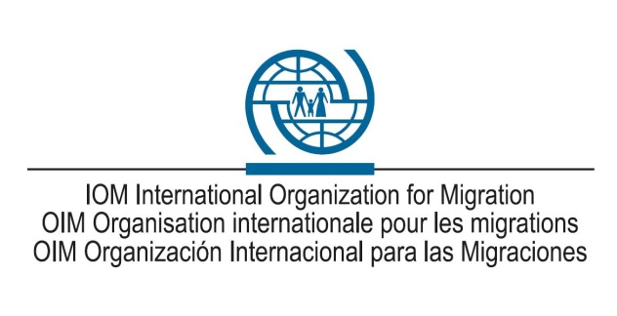
Post Description

I. Position Information
Incumbent  Position title  Position grade  Duty station | Head of Office  NO/A  Ashgabat, Turkmenistan

Appointment type
Position rated on | 18 May 2017 and 27 July 2022
Position number | 20030736
Reports directly to (Full Name of Supervisor and Position Title) | Sub-Regional Coordinator for Central Asia/Chief of Mission, Nursultan (Kazakhstan)

II. Organizational Context and Scope
Under the direct supervision of the Sub-Regional Coordinator for Central Asia in Nursultan (Kazakhstan) and in close cooperation with relevant offices in the field and Units at Headquarters (HQ), the incumbent candidate will be responsible and accountable for promoting, developing and implementing the full range of IOM services and administration and management of the IOM Office in Ashgabat, Turkmenistan.
The incumbent will be responsible and accountable for coordinating the program implementation activities in Turkmenistan in the area of counter-trafficking and assistance to migrants, emergency response and community stabilization, migration and health, migration and border management, migration and emergencies, implementation of the Advance Passenger Information systems, as well as movement/resettlement operations.
Aside from that, the incumbent shall be responsible for cooperating with other UN Agencies accredited in Turkmenistan, developing and implementing of joint programs, and coordinating all actions with Office of UNRC in Turkmenistan and within the existing United Nations Sustainable Development Cooperation Framework (UNSDCF). Together with the UNRC, the incumbent shall serve as the Chair of the United Nations Migration Network in Turkmenistan.
The incumbent will also be responsible for the development, approval, implementation, and coordination of the annual working plans with the Government of Turkmenistan. The incumbent shall ensure that all IOM activities in Turkmenistan are duly covered in local media and through IOM and UN websites, and relevant information is shared with IOM Regional and sub-Regional Offices.
In addition, the incumbent shall be responsible for the resource mobilization activities and related to that liaising with the donors and development partners.

III. Responsibilities and Accountabilities
- Manage administrative, financial, personnel, procurement, logistics, security and other administrative activities. Supervise the related budgetary financial and administrative functions of the Office in accordance with the Organization's regulations and procedures. Supervise the work of staff;

- Monitor the implementation of projects or operations and prepare progress and final reports. Gather information and provide inputs to resolve problems, analyze operational procedures and project effectiveness, and recommend improvements;

- Assist in maintaining working relations with government and local authorities, diplomatic missions, UN agencies, funds and programs, international organizations, non-governmental organizations, voluntary agencies, media and other relevant partners;

- Participate in relevant conferences, workshops, steering committees, policy and technical working groups, as well as other forums to ensure proper coordination and presentation of activities;

- Coordinate the provision of technical support and guidance to relevant governmental authorities; Assist in identifying new programme opportunities and recommend project ideas;

- Assist in the implementation of new project opportunities in close coordination with relevant stakeholders in areas of concern to the Government and in regional context, and design fundraising strategies to address such issues;
- Coordinate the availability of expert resource in the key areas of migration management, strengthening migration management systems; addressing related legislation, regulation and policy concerns; institutional capacity building;

- Prepare regular and specific narrative, briefings, impact, policy, financial, evaluation and statistical reports covering IOM activities. Prepare briefings and background information as required;

- Keep the Sub-Regional Coordinator, Regional Director and HQs fully informed of the activities of the Office;

- Make practical and impactful contribution to the resource mobilization efforts to ensure the availability of funding for smooth and uninterrupted functioning of the IOM Office;

- Serve as the Chair of the United Nations Migration Network in Turkmenistan, coordinate all activities relating to UNMN; and,

- Perform such other duties as may be assigned.

VI. COMPETENCIES
The incumbent is expected to demonstrate the following competencies:
Accountability – takes responsibility for action and manages constructive criticisms
Client orientation – works effectively well with client and stakeholders
Continuous learning – promotes continuous learning for self and others
Communication – listens and communicates clearly, adapting delivery to the audience
Creativity and initiative – actively seeks new ways of improving programmes or services
Leadership and negotiation – develops effective partnerships with internal and external stakeholders;
Performance management – identify ways and implement actions to improve performance of self and others.
Planning and organizing - plans work, anticipates risks, and sets goals within area of responsibility;
Professionalism - displays mastery of subject matter
Teamwork – contributes to a collegial team environment; incorporates gender related needs, perspectives, concerns and promotes equal gender participation.
Technological awareness - displays awareness of relevant technological solutions;
Resource mobilization - works with internal and external stakeholders to meet resource needs of IOM.

IV. REQUIRED QUALIFICATIONS AND EXPERIENCE

Education
- Master’s degree in Law, Political Affairs, Social Sciences, International Relations or a related field from an accredited academic institution; or,
- University degree in the above fields with two years of relevant professional experience in the area of administration and project management.

Experience
- experience working on counter-trafficking and assistance to migrants, emergency response and community stabilization, migration and health, migration and border management as well as movement/resettlement operations issues;
- previous experience in project evaluation and development, and in liaising with other institutions;
- knowledge of migration and human rights issues; and,
- wide working experience in Turkmenistan and knowledge of Central Asia region.

V. Languages
Required  (specify the required knowledge) |  | Advantageous
Thorough knowledge of Turkmen, Russian and English

