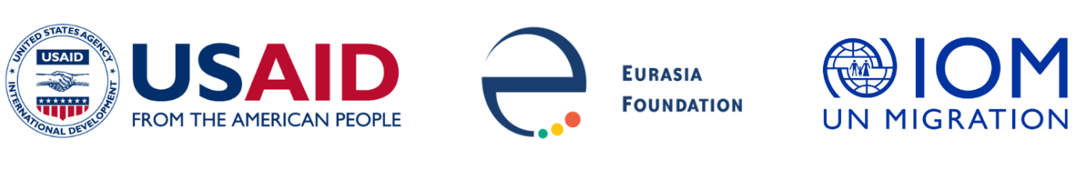

Social Innovation in Central Asia

Notice of Funding Opportunity

Innovative Solution Grants

Background
The International Organization for Migration in Turkmenistan (IOM), in partnership with Eurasia Foundation, announces a notice of funding opportunity for public organizations and associations of Turkmenistan to apply for Innovative Solution Grants. These grants are part of IOM’s “Building Youth Resilience through Community Engagement” project and Social Innovation in Central Asia (SICA), a five-year program funded by the United States Agency for International Development (USAID).

The grants are part of the approved "Annual Action Plan for Cooperation between the Government of Turkmenistan and the International Organization for Migration for 2022".

In order to expand civic engagement and cross-sectoral partnerships in addressing social challenges, Innovative Solution Grants (ISG) will be provided for projects based in new ideas, strategies and/or technologies that contribute to the solution of socially significant problems. ISGs are designed for public organizations and associations proposing new solutions to social problems and civic initiatives that can lead to demonstrable positive change.

Priority Areas
ISGs are flexible and should be based in the needs identified by applicants. However, priority
for project ideas in the following areas will receive preference in upcoming cycles:

- New approaches for creating dialogue and results through cross-sectoral partnerships
- Innovative approaches to advocacy interests of vulnerable groups at the local and national levels and preventing of human trafficking
- Leveraging new technology to solve pressing social or community problems
- Creative or experimental approaches to fundraising in the social sphere
- Creating mechanisms for citizen engagement in solving community problems
- Fostering women’s empowerment
- Promoting gender equality

Eligibility Criteria
Registered public organizations and associations of Turkmenistan are eligible to apply.

Award activities may last for any period of time up to 12 months. Innovative Solution Grant projects are eligible for funding at a maximum of 17,000 USD, but applicants are encouraged to submit cost competitive proposals. Applicants must specify the duration and amount requested in their applications (see below). Applicants may submit only one application per cycle. Applicants who submit more than one application will not be considered.

Application process
All interested applicants must submit a complete application package in Russian by e-mail to the mailbox noted below by the necessary deadline. Prior to submission, applicants must complete an online, self-guided course on Social Innovation and obtain a certificate of completion to be considered eligible to apply. The course is available in Russian and in Turkmen.

Project proposals from organizations must be fully complete in accordance with an application template and include the following information:
- Key information about an applicant and contacts
- Description and justification of the project proposal
- Resumes of key implementers
- Timeline of project activities (Attachment 1)
- Project Logframe (Attachment 2)
- Detailed budget (Attachment 3)
- Scanned copy of the organization’s legal entity certificate of registration

If selected, organizations will need to provide the following additional documentation:
- Scanned copy of the Charter (.pdf or .jpeg or .png)
- Scanned copy of Certification of Absence of Tax Debt
- Proof of the available bank account
- Copy of the passports or ID of the key implementors of the project

If additional information or clarification on applications is needed, the applicant(s) will be notified in writing and will be asked to submit additional information and/or documentation.

EVALUATION CRITERIA
The selection process is open and competitive, and applications will be scored using the following criteria:

- Relevance to the priorities of the competition
- Demonstration of innovative approaches for addressing the issues of public interest
- Clarity of the proposed cross-sectoral partnership
- Relevance and importance of the proposed project subject for society
- Clarity of project design with its feasibility rationale
- Achievement of specific and measurable results within the project stated time frame
- Validity of the project budget

All applicants will be informed of the selection decision in writing. Any questions concerning
Innovative Solution Grants should be submitted in writing to: to gannadurdiye@iom.int and ndavletova@iom.int

Interested organizations must email their applications with “ISG TKM” in the subject line to gannadurdiye@iom.int and ndavletova@iom.int no later than 23:59 Ashgabat-time (GMT+5) on 7 August 2022.

